Rotational Motion Exam
Multiple Choice (5 Points Each)

- According to Newton's Law of Universal Gravitation, gravity is created by -
  - Distance
  - Mass
  - Moment of Inertia
  - Rotation
  - Kinetic Energy
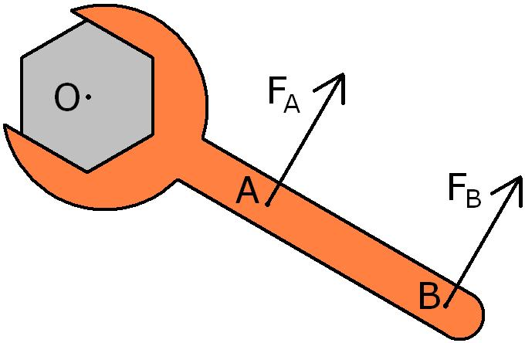

- You are attempting to loosen a bolt from your car by putting a force on a wrench, as shown in the picture. You can choose to put a force on the wrench at point A or at point B. If both the forces are the same magnitude, which force is more effective in loosening the bolt?
  - Force A is more likely to turn the bolt because the force is applied closer to the bolt.
  - Force A is more likely to turn the bolt because F_{A}/r is greater than F_{B}/r.
  - Force B is more likely to turn the bolt because F_{B} has a larger magnitude.
  - Force B is more likely to turn the bolt because it produces a greater torque.
  - Both forces will turn the bolt in the same manner because the magnitude of both forces is the same.

- A wheel spins at a constant rate, and makes 10 rotations in 5 seconds. What is the angular velocity of the wheel?
  - 5π rad/s
  - 4π rad/s
  - 2π rad/s
  - 2 rad/s
  - 5/π rad/s

- Sometimes in flight training for NASA, Astronauts are trained to withstand large accelerations by placing them on a large, rotating table (similar to the wheel used in Wheel of Fortune). They are strapped to the table, and the wheel begins to rotate. Centripetal acceleration causes sensations similar to gravity. Some astronauts can withstand accelerations of 100 m/s² without losing consiousness. Assuming the radius of the table is 1.25 meters, what would the tangential velocity of the table need to be to cause this acceleration?
  - 1.25 m/s
  - 11.18 m/s
  - 64 m/s
  - 80 m/s
  - 100 m/s

- The Earth orbits the sun in 365.24 days. It is 1.496 x 10¹¹ m from the sun. Mercury is 5.791 x 10¹⁰ m from the sun. How long does mercury take to go around the sun?
  - 87.965 days
  - 141.384 days
  - 193.996 days
  - 224.175 days
  - There is not enough information to solve this problem.

- The moment of inertia of an object depends on -
  - The mass of the object.
  - The radius of the object.
  - The shape of the object.
  - All of the above.
  - None of the above.

- A wheel starts from rest and and has an angular acceleration of π/4 rad/s². What is the speed of the wheel when it has made 4 complete rotations?
  - π rad/s
  - 3π/4 rad/s
  - 2π rad/s
  - 4π rad/s
  - 8π rad/s

- An ice skater is spinning on the ice. To go faster, she brings her arms and legs in toward the center of rotation. Why does this action increase her angular velocity?
  - Bringing her arms and legs inward puts a torque on her body, causing her to rotate faster.
  - Her rotational kinetic energy increases because her density increases.
  - The law of conservation of angular momentum requires her angular velocity to increase in order to offset the decrease in moment of inertia.
  - The law of conservation of linear momentum requires her linear velocity to increase in order to offset the decrease in mass.
  - There is no scientific explaination for this phenomenon. It is a subject of continuing debate.

- The Earth has a radius of 6.371 x 10⁶ meters. How far would you have to travel to go from the equator to the south pole? (Assume you travel in a straight line and that the Earth is a perfect sphere.)
  - 1.013 x 10⁶ m
  - 6.371 x 10⁶ m
  - 1.001 x 10⁷ m
  - 1.274 x 10⁷ m
  - 4.056 x 10⁷ m

Multiple Correct Multiple Choice (5 points): In the following question, there are two correct answers. Select BOTH answers that are correct. No credit will be given for incorrect or partially correct answers.
- Which of the following are implications of Keppler's laws?
  - Planets travel along elliptical orbits.
  - Planets travel faster when farther from the sun.
  - Planets that are closer to the sun take longer to go around the sun.
  - The orbit of a planet's moons can be predicted by comparing them to the planet's orbital period.

Free Response (10 Points Each)
- You are in a spaceship hovering at the cloud-tops of Jupiter (r_{jupiter} = 6.991 x 10⁷ m). You have a mass of 70 kg.
  - What is the force of Jupiter's gravity on you?

  - What is your acceleration due to Jupiter's gravity?

. .
o

- A 5-meter long board has a mass of 20 kg, and is placed over the edge of a building so that 2 meters of the board are overhanging the edge. A man stands on the board, as shown in the picture. How far can a 75 kg man walk past the edge of the building before the board falls?


- Noah is on a riverboat when he falls overboard. He grabs on to the paddle-wheel at the back of the boat, hoping to be raised above the water. He experiences a centripetal force of 918.75 newtons. If Noah's mass is 75 kg, what is the speed that the wheel is turning?

- A torque of 13 m x N acts on a solid cylinder with a radius of 1.2 m. It has a mass if 15 kg.
  - The moment of inertia of a solid cylinder is given by . What is the moment of inertia of the cylinder?

  - What is the angular acceleration of the cylinder?

  - How far does the cylinder roll in 7 seconds?

- The star Gliese 876 is known to have at least four planets. The first planet orbits at a distance of 3.11263054 × 109m, and takes 1.938 days to orbit the star. The second planet orbits once every 30.008 days. How far from the star is the second planet?

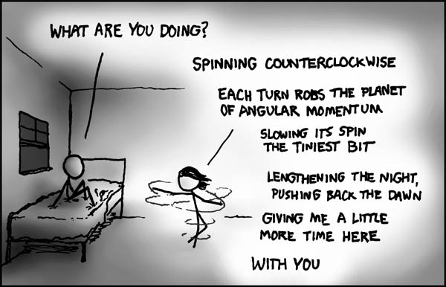
- Bonus Question: Write a paragraph that explains the comic above.

- Bonus Question: Name the musical based on the name of a lead character(s) and a song they sing.
  - Christine, “Angel of Music” __________________
  - Grizabella, “Memory” ____________________
  - Roxie Hart - “Funny Honey” _________________
  - Fantine, “I dreamed a Dream” _________________
  - Tevye, “If I were a Rich Man” ___________________
  - Danny and Sandy, “You're the one that I want” ___________________
  - Tracy, “Good Morning Baltimore” ___________________
  - Mother Abbess, “Climb Every Mountain” ___________________
  - Eva Peron, “Don't cry for me Argentina” ______________________
  - Guy, “Land of 1000 Dances” _________________________

